Erasmus+ YE
Exploring the Impact of Wasted Food
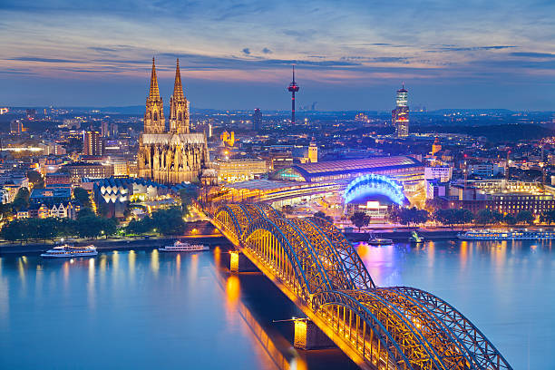
30 November (arrival) – 07 December (departure) 2026, Germany
1. The motivation for the organization of the Youth exchange?
The motivation to organise this Youth Exchange comes from the need to move young people from simply knowing about environmental problems to becoming active participants in creating solutions. Food waste is not only an environmental issue; it is also connected with consumption habits, social responsibility, community solidarity and the way young people participate in society. We believe that young people need practical opportunities to explore these connections, question their everyday behaviours and develop realistic actions that they can continue in their local communities. A Youth Exchange is particularly suitable because it creates a safe and intercultural learning environment where young people can learn from one another rather than only receive information from trainers. Participants from six organisations and different European backgrounds will be able to compare how food waste is understood and addressed in their countries, share local practices and discover both common challenges and different solutions. This European dimension will help participants understand that environmental challenges are shared across borders and require cooperation, responsibility and collective action.
The project will use non-formal education methods such as simulations, team challenges, discussions, creative tasks, problem-solving activities, reflection and practical environmental actions. Participants will explore food waste prevention, responsible consumption, food sharing, reuse and recycling while developing communication, teamwork, critical thinking, creativity and intercultural competences. The learning process will encourage participants to connect environmental responsibility with inclusion and community participation, demonstrating how food can also become a tool for bringing young people together. Another important motivation is to empower participants to become multipliers. During the Exchange, they will not only acquire knowledge for themselves but will develop ideas and practical activities that can be transferred to their schools, youth organisations, communities and social networks. Each participant will be encouraged to identify at least one realistic action that can be implemented after returning home.

2. The needs of the YE

PROJECT NEEDS:
Need for stronger environmental awareness among young people
Young people need a better understanding of how everyday consumption, food waste and disposal practices contribute to environmental pollution, climate change and the unnecessary use of natural resources.
Need for practical knowledge on preventing food waste
Many young people have general awareness of sustainability but lack practical skills and simple methods for planning consumption, reducing unnecessary food waste, reusing food and managing unavoidable waste responsibly.
Need to change everyday behaviours and consumption habits
There is a need to help young people move from awareness to action by encouraging responsible purchasing, consumption, sharing and disposal habits that can be realistically applied in their daily lives.
Need for active youth participation in environmental action
Young people need opportunities to participate in practical environmental activities where they can identify local problems, develop solutions, work in teams and take responsibility for actions in their communities.
Need for intercultural exchange of environmental practices
Young people from different European countries need opportunities to compare their experiences, national approaches and local solutions related to food waste and environmental protection. International cooperation can help them discover new perspectives and transferable practices.

3. The organizer:
MIGRAFRICA

Migrafrica was founded and led by former refugees and came to life in 2013 aiming at facilitating the integration and participation of mainly African refugees in Germany and Europe to the social, political and economic life in their welcoming host communities. The main activities of Migrafrica revolve around direct support to refugees, help professionalize migrant diaspora organizations and facilitate the link between migration and sustainable development. Migrafrica with its unique experience in working with refugees and working on legal paths to come to Europe, will provide a very key and important information about the consequence of irregular and dangerous migration paths (routes) and how refugees can come to Europe in more regulated and less dangerous ways.
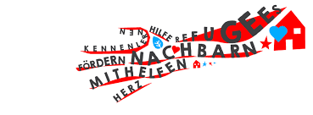

For more info please visit the coordinator website: https://www.migrafrica.org/

4. Participant profile:

Profile of the participants:
Each national team should be represented by 6 participants in total (5 participants and 1 national leader), gender balance (3+3) 50-50 % need to be managed and organized. ( 5 participants aged 18-30 and 1 national leader +18 – MANDATORY!)

For the participants’ selection the following criteria will be taken into consideration:
➢ Mix of existing and experienced participants but also participants who are new or newish to the topic but interested in the process of social inclusion, inclusivity and youth leadership
➢ Demonstration of social sensibilities (socially active YOUTH LEDAERS, YOUTH WORKERS, EMPLOYERS IN THE ORGANIZATIONS with a role in local communities and interested in the topic of the project).
➢ Participants particularly active at Li local level, running youth empowerment initiatives.
➢ Ready to actively participate in the whole project (preparation, participation in the YE and follow-up activities).
➢ Ready to share personal intercultural stereotypes and experiences and analyze them from different perspectives.
➢ Experienced or interested in working with Erasmus+ program

5. What activities will be organized during the YE:

Ice breakers, Energizers, Presentation of the Erasmus+, Youth pass certificate, Debates, Role play, Rising public awareness campaign, Presentation of National practices, Panel expert discussion, Cultural visit, Practical visit in the field of Entrepreneurship, Video creation – Instagram Reals, and dissemination materials for promotion, Follow Up, Dissemination activities, Reflection and Intercultural night.
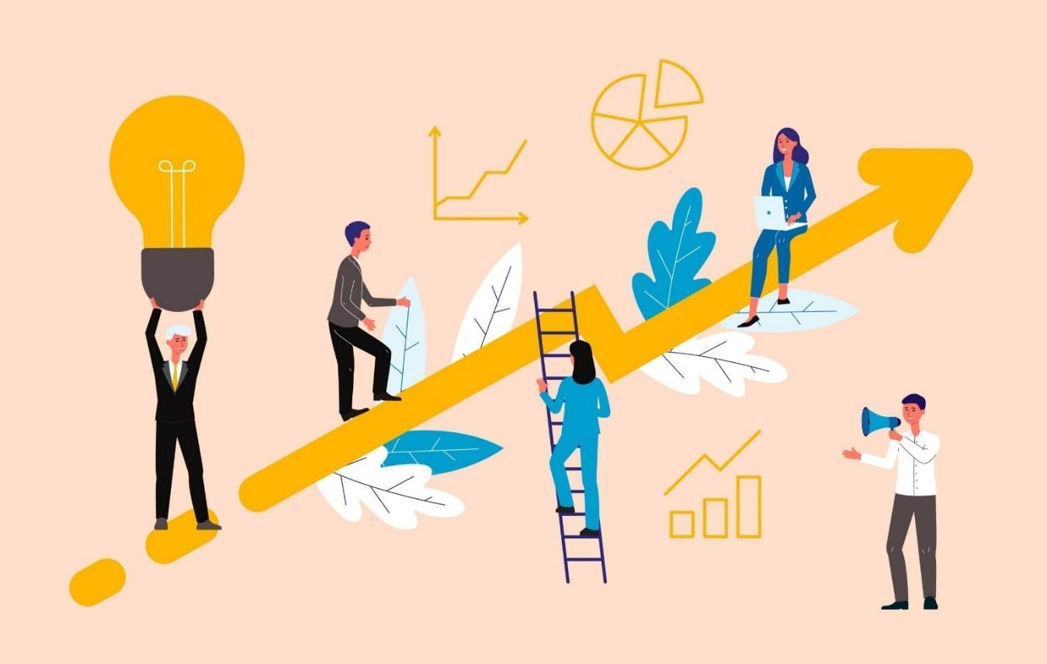

6. WHERE? ACCOMMODATION INFO
The participants will be accommodated at STATION BACKPACKER`S HOSTEL - Marzellenstrase 44-56, 50668 Cologne Germany +49 221 9125301 - phone for contact .
(https://www.hostel-cologne.de/home.html - for more information regarding the accommodation).
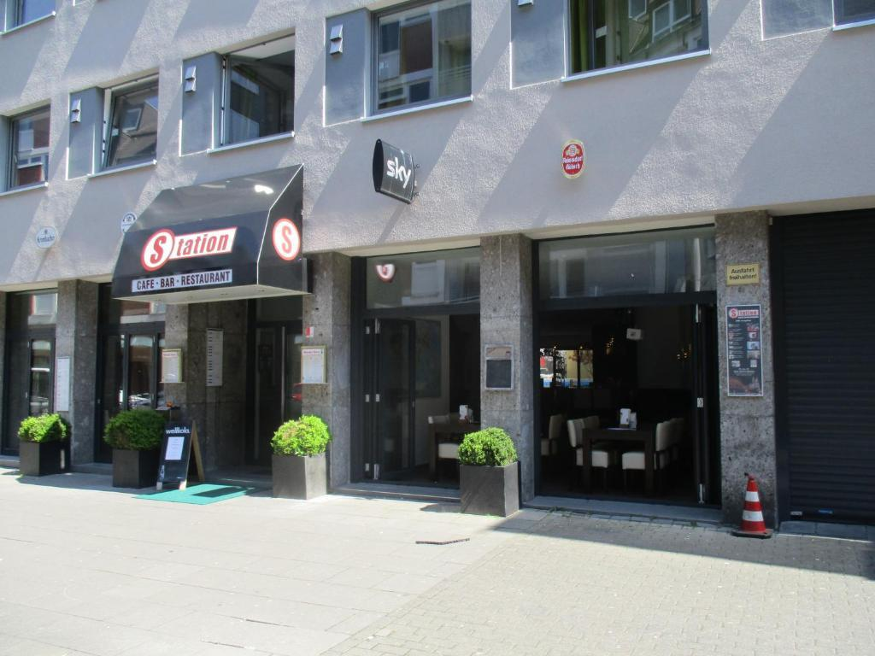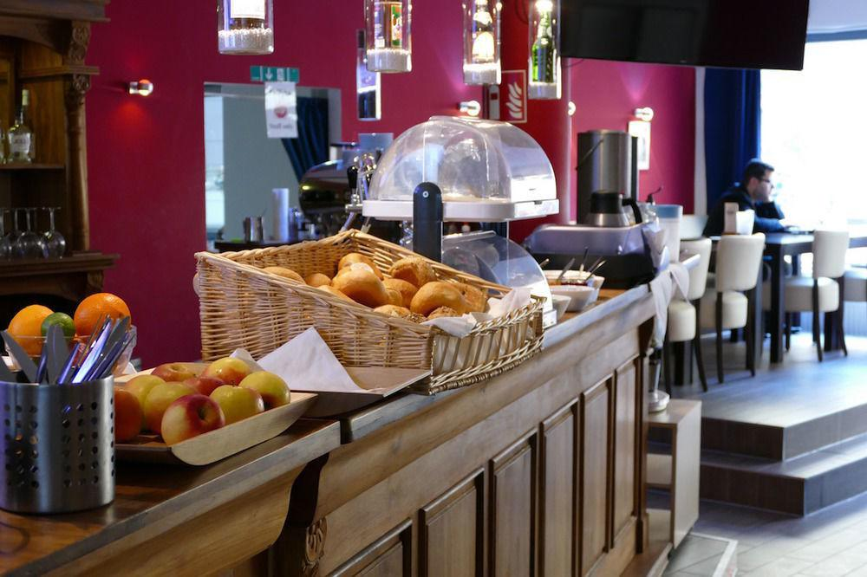

We will offer support and information on how you can reach the hostel. ALL THE INFORMATIONS WILL BE PROMOTE IN THE ONLINE GROUP FOR COOPERATION.

7. THE HOST CITY – COLOGNE - GERMANY
Cologne (Köln) is Germany’s fourth-largest city, located on the Rhine River in the state of North Rhine-Westphalia. With around 1.1 million residents, it’s a major cultural, economic, and historic center of western Germany. Founded by the Romans as Colonia Agrippina, Cologne has over 2,000 years of history and was a major city in the Holy Roman Empire and Hanseatic League.
Its most iconic landmark is the Cologne Cathedral (Kölner Dom), a UNESCO World Heritage Site and one of the most visited churches in Europe. The city is also known for Eau de Cologne, its Romanesque churches, museums, and vibrant art and media scenes. Despite being heavily bombed during WWII, many historical sites were restored.
Today, Cologne is a hub for education, research, and industry, home to top universities, science institutes, and major corporations like Lufthansa. It also hosts international trade fairs and events, making it a dynamic and diverse metropolis at the heart of Europe.
For more info visit the link:
https://www.youtube.com/watch?v=FZv0F5ucwag

8. FINANCIAL CONDITIONS


Accommodation, food and the coffee breaks are 100 % covered by the Erasmus+ Program. Travel cost is budgeted according Erasmus+ conditions:

Germany – 23 EUR
Bulgaria – 309 EUR
Lithuania – 309 EUR
Romania – 309 EUR - Green travel option 417 EUR
Turkiye – 395 EUR
N Macedonia - 309 EUR

VERY Important!
- You can have max. 2 extra travel days before or after the project. Tickets exceeding this date limit cannot be reimbursed. The costs for the extra days are covered by yourself
- It is compulsory for participants to have travel and health insurance (not covered by project)!
- Please note that all partner organizations need to select and buy tickets for participants before 15 of October 2026
REBURESMENT PROCEDURE:
- EACH PARTICIPANT NEED TO ATTACH THE BOARDING PASSES AND THE INVOICES FROM THE TRAVEL TRIP (the information of the reimbursement will be explained in the details during the TC).
- EACH NATIONAL GROUP AND PARTICIPANT AFTER THE FINISHING OF THE PROJECT WILL HAVE TASKS TO:
- Create and design promotion material (pictures and short video from the project) and promote on social media, private blog or media
- Organization of FOLLOW UP EVENT WITH 30 PARTICIPANTS is MANDATORY after the competition of the project with promotion of the results of the project with confirmation of promotion materials like pictures (these materials need to be promoted on social media or web sites of the partners).
- AFTER SHARING THE PROMOTIONAL LINKS AND MATERIALS OF THE TASKS NUMBER 2 AND 3 THE COORDINATOR WILL REBUSTMENT THE TICKETS FOR YOUR PARTICIPATION DURING THE PROJECT.
MORE INFORMATION FOR THE DISSIMINATION * IDEAS FOR DISSIMINATION AND PROMOTION OF THE RESULTS YOU CAN FIND AT THE SECTION NO 10.

9. PREPARATION & THINGS TO BRING

Travel documents – Bring all travel documents with you! – Boarding passes, bus tickets, train tickets.
NGO MARKET – PLEASE, leave the power points and your promo videos at home. In the real world, we often have only a few minutes to explain our work to policy makers, to youngsters and others. Sometimes it is difficult to explain quickly the objectives of your work, to give a description of your target group or to present what is so unique in your work and what the priorities are. We suggest you to be KISS: Keep It Simple and Short!
CULTURAL night – Any kind of activities are welcome (Kahoot quiz, video presentations, dances, songs, games, posters, flyers etc.). TAKE YOUR NATIONAL FLAG!
Clothes – We don't have any dressing code at our training. So, feel free to take whatever clothes make you feel comfortable.

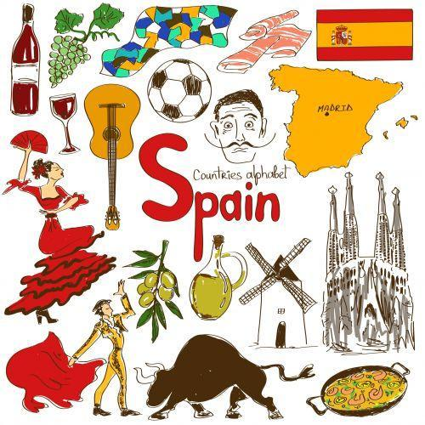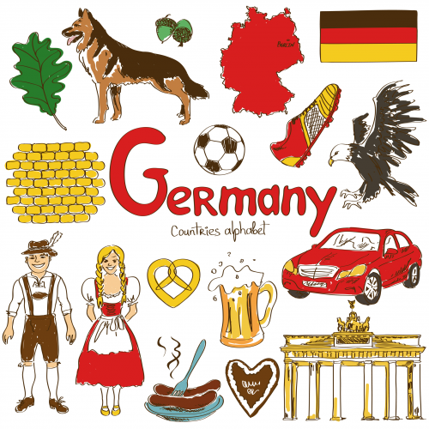

10. DESSIMINATION AND PROMOTION OF THE PROJECT
Project promotion and dissemination is an important process during the cooperation, participants and organizations will have OBLIGATION and the task to promote the project output, activities and the results through the following process:
- Promotion through the websites of the partner organizations
- Promotion through social media – promoting pictures and videos - Instagram, Facebook, Tick Took, YouTube
- Promotion through media, radio, television
- Promotion of a project poster with information about the project
- Promotion through public events
- Promotion in schools, universities and cooperation centers

11. COOPERATION AND REGULATIONS
WhatsApp group for cooperation:
PLEASE ONLY SELECT PARTICIPANTS TO JOIN THE GROUP! – IMPORTANT!
https://chat.whatsapp.com/H6RxNQOtV1Y2UStiXEHCEF

Online registration for the Youth Exchange KA152 (obligatory):
https://forms.gle/5tkAG4mK6raMuVR39

PLEASE ONLY CONFIRMED AND REGISTRED PARTICIPANTS!

Contact: Abraham Nida
nida@migrafrica.org, info@migrafrica.org

SEE YOU SOON IN COLOGNE!

